PHASE 1 SUMMARY REPORT
Foundation & Exploration (Weeks 1-3)
Heavy Supplier, Inventory & Warehouse Analytics | CadetX Virtual Work Experience
Item | Detail
Prepared by | Keren Oyem, Data Analyst / Data Scientist
Sprint | Week 3: Fri 6 Nov - Thu 12 Nov 2026
Task | Baseline KPIs and Phase 1 summary (closes Phase 1)
Data period | January 2019 - December 2024 (reference date 31 December 2024)
Currency | Indian Rupees (INR); crore = 10 million
Source | docs/kpi_tracker.xlsx (48 KPIs), warehouse.duckdb, Week 2 issue log

1. Purpose and scope
This report closes Phase 1. It records what the foundation work delivered, how reliable the data is, and where the business stands before any improvement work, using the baseline KPI tracker. It also sets the priorities for Phase 2 (product, inventory and warehouse analytics).

2. What Phase 1 delivered
Week | Catalogue tasks | Main deliverables
1 | A1 Data Profiling | All 12 tables profiled; keys, nulls and data types reviewed; first list of data-quality concerns.
2 | A2 Cleaning, A5 Validation, G4 Integrity | Clean layer of 12 Parquet files; 107 automated tests; 28 issues logged, each with a decision (5 fix, 8 flag, 13 accept, 2 exclude).
3 | A3 Integration, A4 Features, A6 Dictionary | Star schema (5 dimensions, 4 facts) validated against source; 8 feature tables with a feature library; data dictionary covering 29 tables; baseline KPI tracker with 48 KPIs.

3. Data quality summary
The structure of the data is sound: all 17 foreign keys resolve, every order line reconciles to its header, and GST arithmetic is exact. The weaknesses are in identifiers and stored summary fields, not in the transactions. Each was documented and handled without deleting any row.
Issue | Effect | Treatment
invoice_id re-issued on 197 invoices; payment_id on 202 payments | 393 invoices cannot be matched safely to payments | Flagged; invoices joined on so_id; ambiguous invoices excluded from payment KPIs
Stored payment_status wrong for 67 invoices | Paid invoices that are only partly paid | Status derived from payments
Stored customer purchase value | About 4% of recomputed sales, correlation -0.08 | Recomputed from delivered orders; original not used
Cancelled orders and POs | Placeholder delivery dates; no receipt dates | Kept and flagged; excluded from revenue, delay and lead-time KPIs
Stock adjustments have no direction | Gain or loss unknown (2,454 records) | Left out of stock KPIs (small against 20 million units received); open question
Overpaid invoices (52) and stock differences (14 pairs) | Cause unknown | Flagged; need a business answer

Three questions remain open and depend on the official Fields Documentation: the direction of stock adjustments, the cause of overpayments, and the genuine differences between recorded and ledger stock.

4. Baseline KPIs
The tracker holds 48 KPIs in five areas, by year for 2019-2024, for the whole period and for the latest year (2024). Table 1 shows the headline set. Revenue counts delivered orders only, before GST. Sales, finance and supplier KPIs in the last column are pooled over all years; inventory and warehouse KPIs in that column are the average of the six yearly values.
Table 1. Headline baseline KPIs
KPI | Unit | 2019 | 2023 | 2024 | 2019-2024
Orders delivered | count | 3,031 | 3,022 | 2,956 | 18,033
Revenue (before GST) | INR crore | 387.0 | 382.5 | 367.8 | 2,295.9
Gross margin % | % | 21.6 | 21.6 | 21.6 | 21.6
Average order value | INR | 1,276,812 | 1,265,611 | 1,244,247 | 1,273,165
SO cancellation rate | % | 9.1 | 9.7 | 10.9 | 9.8
Collection rate | % | 80.8 | 80.0 | 79.9 | 79.7
Late payment rate | % | 41.3 | 40.4 | 42.8 | 41.7
On-time delivery rate | % | 84.5 | 84.7 | 84.9 | 84.9
Average lead time | days | 18.2 | 17.8 | 17.8 | 17.9
PO cancellation rate | % | 9.2 | 10.3 | 10.1 | 9.9
Supplier concentration (HHI) | index | 1,254 | 1,253 | 1,252 | 1,250
Closing inventory value | INR crore | 4,520 | 23,323 | 27,877 | 16,242
Inventory turnover | times per year | 0.133 | 0.014 | 0.011 | 0.041
Days of inventory on hand | days | 2,746 | 25,477 | 32,395 | 17,099
Receipts-to-issues ratio | ratio | 17.4 | 18.3 | 18.1 | 18.0
Operating cost-to-revenue | % | 4.4 | 4.5 | 4.6 | 4.5

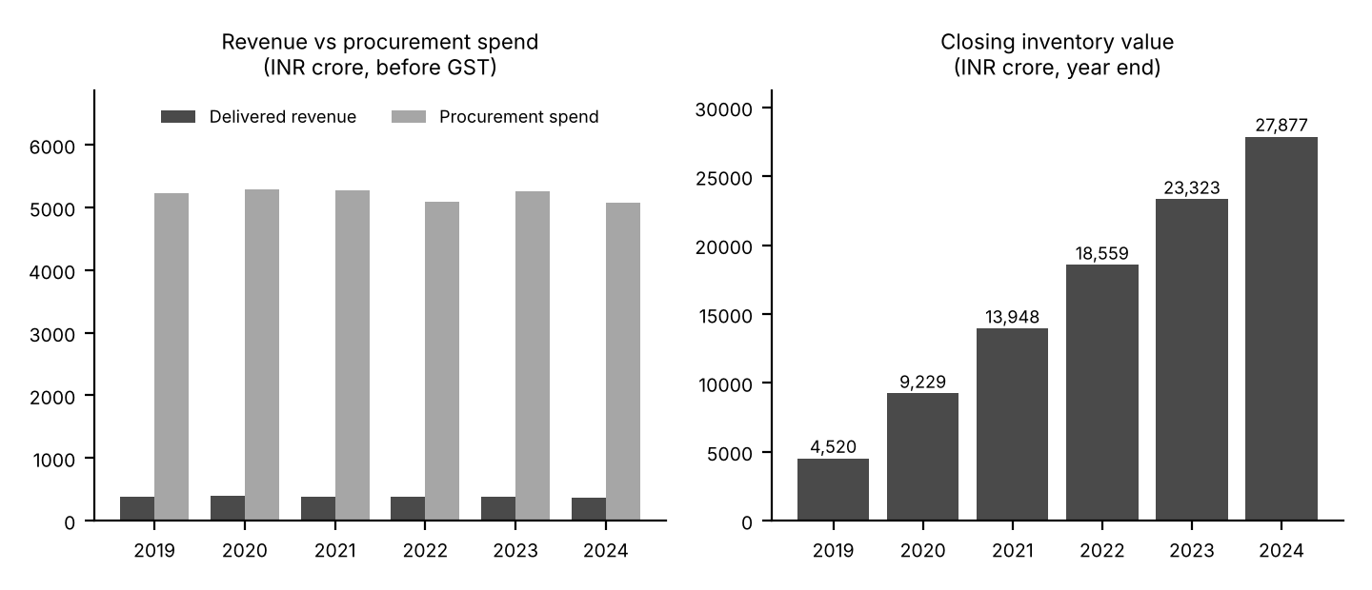
Figure 1. Procurement spend is more than 13 times revenue, and closing inventory value grows every year.

5. Key findings

Finding 1: stock builds up far faster than it sells (high priority)
The warehouses receive about 3.37 million units a year and issue only 0.19 million, a ratio of 18.0 to 1. Closing inventory value rose from INR 4,520 crore in 2019 to INR 27,877 crore in 2024 (6.2 times), and 99.7% of it (INR 27,793 crore) sits above the maximum stock level. Over six years procurement spend was INR 31,203 crore against a cost of goods sold of INR 1,801 crore (17.3 times). Inventory turnover has fallen from 0.133 to 0.011 times a year, which equals 32,395 days of stock on hand in 2024. No product-branch pair is below its reorder level and none is dead stock, so the problem is excess, not shortage.

Finding 2: revenue is drifting down while margin holds
Delivered revenue fell from INR 387.0 crore in 2019 to INR 367.8 crore in 2024 (5.0% lower; 3.8% lower than 2023). Delivered orders fell 2.5% and average order value 2.6%. Gross margin is steady at 21.6%. The sales order cancellation rate rose from 9.1% to 10.9%.

Finding 3: cash collection is incomplete and mostly overdue
Of INR 2,860 crore invoiced on unambiguous invoices, 79.7% has been collected, leaving about INR 580 crore unpaid. Of the outstanding balance, 98.4% is past its due date at 31 December 2024; every year from 2019 to 2023 shows 100%, so old balances are not being closed. Among fully paid invoices, 41.7% were paid late and customers take 32.3 days on average to pay. The DSO figure of 74 days is only a proxy (see section 6).

Finding 4: suppliers are fairly reliable and not concentrated
Suppliers deliver on time 84.9% of the time, with an average delay of 0.5 days and a 90th percentile delay of 3 days. Average lead time is 17.9 days with a standard deviation of 6.7. POs are cancelled 9.9% of the time. Supplier spend is spread almost evenly: the concentration index is 1,250, equal to a perfectly even split across eight suppliers, and the largest supplier holds 12.9% of spend. This is a company-level view; concentration by product and category is tested in Week 7. POs are priced 4.4% below master cost, but import duty adds 9.5%, so landed cost is about 4.6% above master cost.

Finding 5: the customer base looks stable
About 499 of 500 customers buy every year, with average retention of 99.8% and churn of 0.16%. Average credit utilisation is 50.0% and no customer is over its limit. A year-on-year view hides risk when nearly everyone buys every year, so Week 8 will use a 180-day inactivity definition for churn.

Finding 6: warehouse efficiency is steady but revenue per square foot is slipping
Operating cost is 4.5% of revenue (4.4% in 2019, 4.6% in 2024). Revenue per square foot fell 5.0%, from INR 17,118 to INR 16,269. Each employee handles about 94 stock movements a year. These are baselines for the branch benchmarking in Week 6.

6. Limitations and assumptions
- Synthetic-data artefacts. The extreme overstock and the near-perfect customer retention are likely features of generated data. They are reported as findings with their evidence, not hidden.
- DSO is a proxy. It is outstanding divided by invoiced, times 365. A true period-end DSO needs a payment timeline and is planned for Week 8.
- Stock excludes adjustments. Their direction is unknown; they total about 67,000 units against about 20 million received.
- Branch operating cost is constant. The branch master holds one current value, so it is applied to every year.
- Import duty rate is assumed to be a percentage. To be confirmed with the Fields Documentation.
- Definitions of master-table fields are inferred. The Fields Documentation was not available; the data dictionary marks which definitions are verified and which are inferred.

7. Priorities for Phase 2
Week | Focus | What to establish | Priority
4 | Product performance and demand | Which products give 80% of revenue and margin; demand trends and seasonality; ABC-XYZ classes using the demand-variability features | Medium
5 | Inventory health | Root cause of the 18:1 receipts-to-issues imbalance; stock rebuilt from the ledger; excess capital (INR 27,793 crore) by product and branch; rebalancing options | High
6 | Warehouse operations | Branch benchmarks on space, throughput and cost; space use from product volumes | Medium

Receivables, supplier risk and customer segmentation follow in Phase 3 (Weeks 7 and 8), using the payment, supplier and customer features already built.

8. Phase 1 checkpoint
Criterion (Definition of Done) | Status
Every table profiled and every join key validated | Complete (Weeks 1-2)
Clean data layer rebuilds from raw with one command; tests pass | Complete (Week 2)
Each fact table reconciles to source row counts and totals | Complete: all validation checks passed
Feature library and data dictionary delivered | Complete
Baseline KPI tracker published | Complete: 48 KPIs
Foundation signed off before analytics begins | Ready for sign-off

